OS Coding Project2

Part1

1. Compile parse1.c

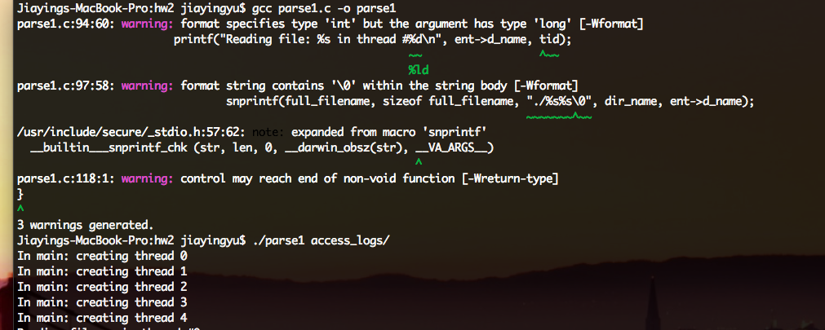

1. The program concurrently reading the files in the directory. We do not print file content to make screen output clean and concise.

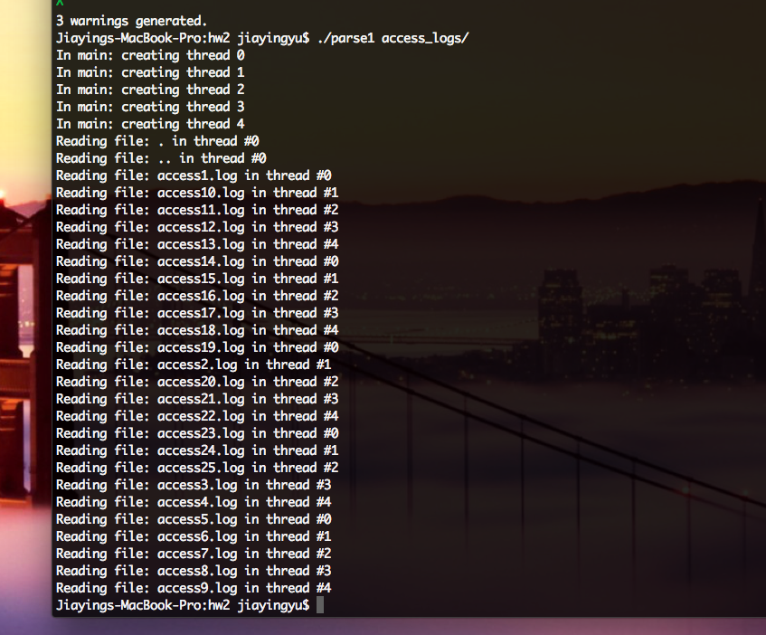

Part2

1. Compile both parse2.c and strmap.c

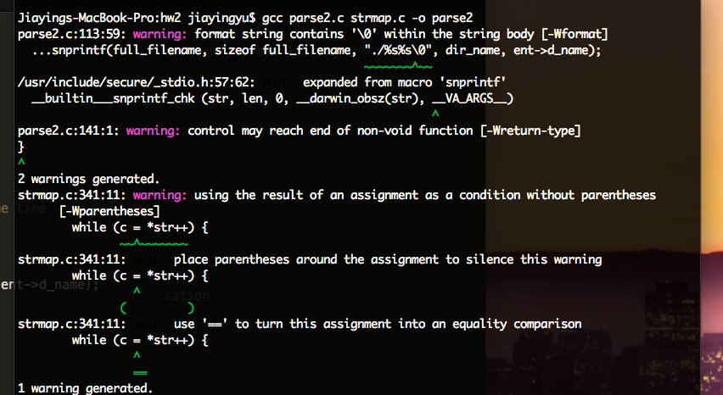

1. 5 threads concurrently reading files using mutex for synchronization. Total unique IP count is 182.

